AACB Website Customisations

Copyright Notice
Updated on 5/11/22.
©2022 Advanced Solutions International, Inc. All rights reserved.
Updates may be made to this material and incorporated into later editions.
Worldwide Sales Headquarters
901 N. Pitt St., Ste. 200 | Alexandria, VA 22314 | 800.727.8682
Center for Technical Excellence
Stonelake Building 1, 4030 West Braker Lane, Suite 175
Austin, TX 78759 | 800.727.8682

Help and Communities  - Support (http://advsol.com/support)  - Customers (http://imis.com)  - Developers (http://imiscommunity.com)  .NET Connected Logo  The Microsoft .NET Connected Logo indicates an application or service whose primary functionality is exposed through, or is programmatically enhanced by the consumption of, Web services that comply with industry Web service standards. These applications must also be built on the .NET Framework, a component of the Windows operating system that enables the use of Web services and next generation Windows applications. This certification recognizes solutions that fully support Web service capabilities, and takes advantage of the .NET Framework programming model benefits such as multi-language support, added security, and enhanced flexibility - benefits that customers will also realize. Microsoft and the .NET Logo are trademarks, or registered trademarks of Microsoft Corporation in the United States and/or other countries. | Notice  This document and the products it describes are confidential information that is furnished under the terms of a license agreement as Software and associated documentation. They may be used and copied only in accordance with the terms of the license agreement. No part may be copied, transmitted, or reproduced in any form without written permission from Advanced Solutions International, Inc. (ASI).  ASI and the program authors have no liability to the purchaser or any other entity, except as provided in the license agreement permitting your use of this software, with respect to any liability, loss, or damage caused, directly or indirectly, by this software or reliance on this documentation, including but not limited to any interruptions in service, loss of business, anticipatory profits, or consequential damages.  Should this document be marked Draft or describe our plans or products not released for general sale to new customers, by reading it you agree not to use this information for any purpose except to educate you and your organization about the current development intentions of ASI; you agree not to rely upon this information, even for planning purposes, since it can be changed at any time without any notice to you; and you agree not copy, publish, or disseminate the information in this document outside your organization without our written consent.  Trademarks  iMIS is a registered trademark of Advanced Solutions International, Inc. Express!, iMIS e-Series, iMIS LAN, CyberiMIS, iMIS.com, iMIS for SQL Server, and iMIS for SQL Express are trademarks, servicemarks, and designmarks of Advanced Solutions International, Inc. Also, iMIS e-X (where X is the name of the module, such as e-Orders) is a trademark, servicemark, and designmark of Advanced Solutions International, Inc. All companies and products mentioned herein are trademarks or registered trademarks of their respective owners.

Contents
General: RiSE Knowledge 4
General: Custom theme and template 5
General: Headings and links 6
General: Custom page layouts 7
General: Internal Banner 9
Homepage: CTA Links 10
Homepage: Link dropdown 11
Homepage: Upcoming Events 13
Homepage: Latest News 14
Homepage: Scrolling logos 15
Footer: Sitemap links and copyright date 17

General: RiSE Knowledge

This document outlines and documents the customisations made to the theme and homepage as part of the Advanced Design Package, and the best practices for updating this content in the future.

It does not cover any out-of-the-box processes or set-ups.

It is advised that the user should have taken the iMIS RiSE for Content Managers training at a minimum, and have some knowledge of basic HTML and CSS elements like links, spans and the style property.

General: Custom theme and template

A custom theme was created for AACB, named AACB_Toronto.
It is designed to be used with the custom website template AACB_CitiesResponsive, which also uses a custom website layout, AACB_CitiesResponsiveLayout.

A Master Styling page was created to show the styling and some customisations added to the site. This is located at @/Web/Master Styling. View this in the public site to see the button and heading options.

General: Headings and links

You can add a blue, yellow or purple line underneath any heading by adding the class blue-line, yellow-line or purple-line to the HTML iPart. It will apply to all headings inside the iPart.

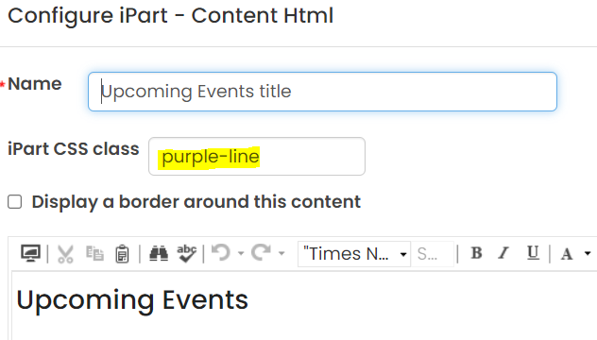

To add an arrow to a link, create the link using the Content Link Manager and add the class readMore in the CSS class field.
To change the arrow colour, add either purple, yellow or blue in addition.

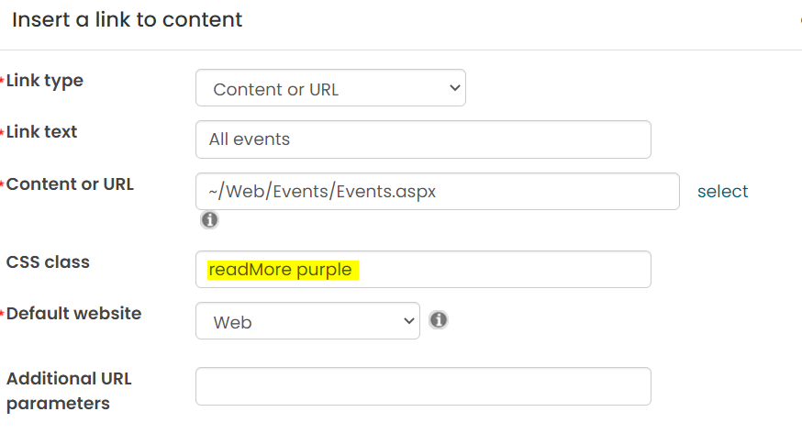

General: Custom page layouts

Full width rows may be created by adding the class Wrapper-FullWidth to any page (in the Page container CSS class field on the Properties tab). This will also remove the secondary menu on the page.
You can then add background images and set colours per row using a custom page layout.

The homepage uses a custom layout (_Homepage) as an example. Create a custom page layout, then save and re-open it. Click the ‘Create custom layout’ link beneath the preview.

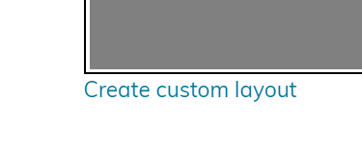
To add a full-width background or colour, add a <div> around the desired row and give it the class row-wrapper.

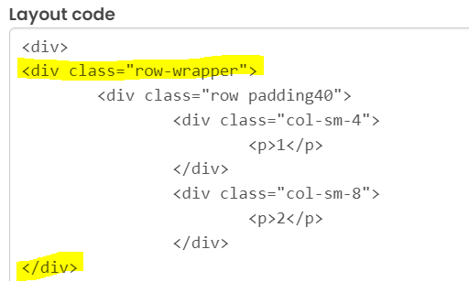

To add a background image, add the background image as a style directly to the row wrapper.

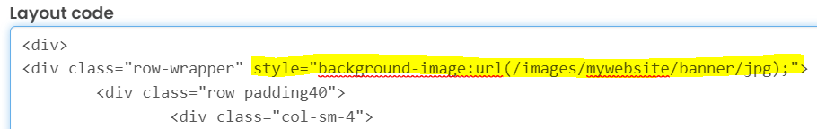
You may find it easier to put the image into an HTML iPart on a dummy content page and copy/paste the image URL from there into the page layout.

Available classes:
padding40 – Adds 40px of padding to the top and bottom of the row
padding60 – Adds 60px of padding to the top and bottom of the row
padding80 – Adds 80px of padding to the top and bottom of the row
overlay – Adds a 25% black overlay and makes all text in the row white. Use if there is text over a background image.

General: Internal Banner

The internal banner references the @/Web/ContentAreas/Internal Full Width Area page as the default.
Javascript (InternalBanner JS) is used in the website template to enable overriding of the title and image per page.

If you would like to change the image used on an individual page, you can assign a Metatag image to that page on the Properties tab.

To change the default image for the whole site, upload a new image into the Image Manager to override images/MyWebsite/banner.jpg

Ideal size for banner images is 1400px x 200px.

To also show the title of the page, add the class showTitle to the Page container CSS class field on the Properties tab.

If you want the wording to be different from the actual page title, you can type the desired title into the TitleOverride field on the Properties tab.

To completely remove the banner from a page, add the class noBanner to the Page container CSS class field on the Properties tab.

Homepage: CTA Links

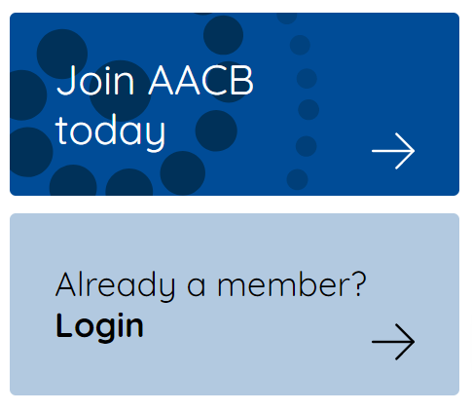

The Call To Action links must be edited in HTML view to preserve the styling.
They are Content HTML iParts with the class CTA, containing a link with extra spans around the content within for styling, but you do not want to accidentally delete these spans by editing from Design mode.
CTA creates the light blue CTA, and adding dark creates the dark blue version.

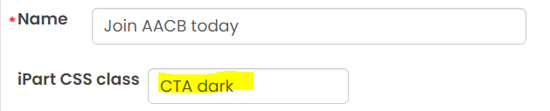

To change the text:
Edit the text inside the span

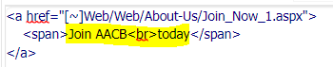

To change the link destination:
Edit the URL in the link tag between the double quotes. You may find it easier to create another link with the Content Link Manager on another tab, and copy/paste the new link.

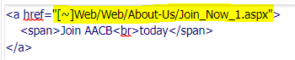

Homepage: Link dropdown

The link dropdown MUST be edited in HTML mode to preserve the HTML structure.

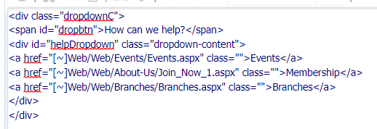

The Javascript required for the dropdown to function is inside the iPart labelled Dropdown JS on the homepage.
This should not be deleted and must be located beneath the iPart containing the dropdown text in order to work.

To edit the default option:
Edit the text in the dropbtn span

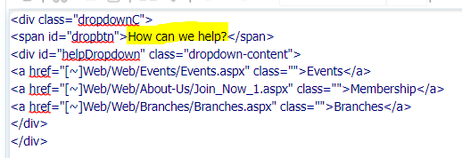
To add or remove an option:
Delete or copy and paste a link inside the dropdown-content div

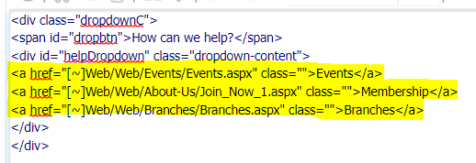

To change a link destination:
Edit the URL in the link tag between the double quotes. You may find it easier to create another link with the Content Link Manager on another tab, and copy/paste the new link.

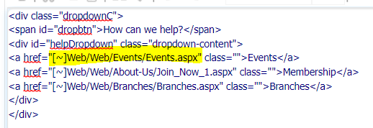

To change the text:
Edit the text inside the link tags

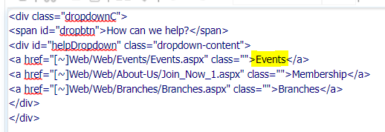

Homepage: Upcoming Events

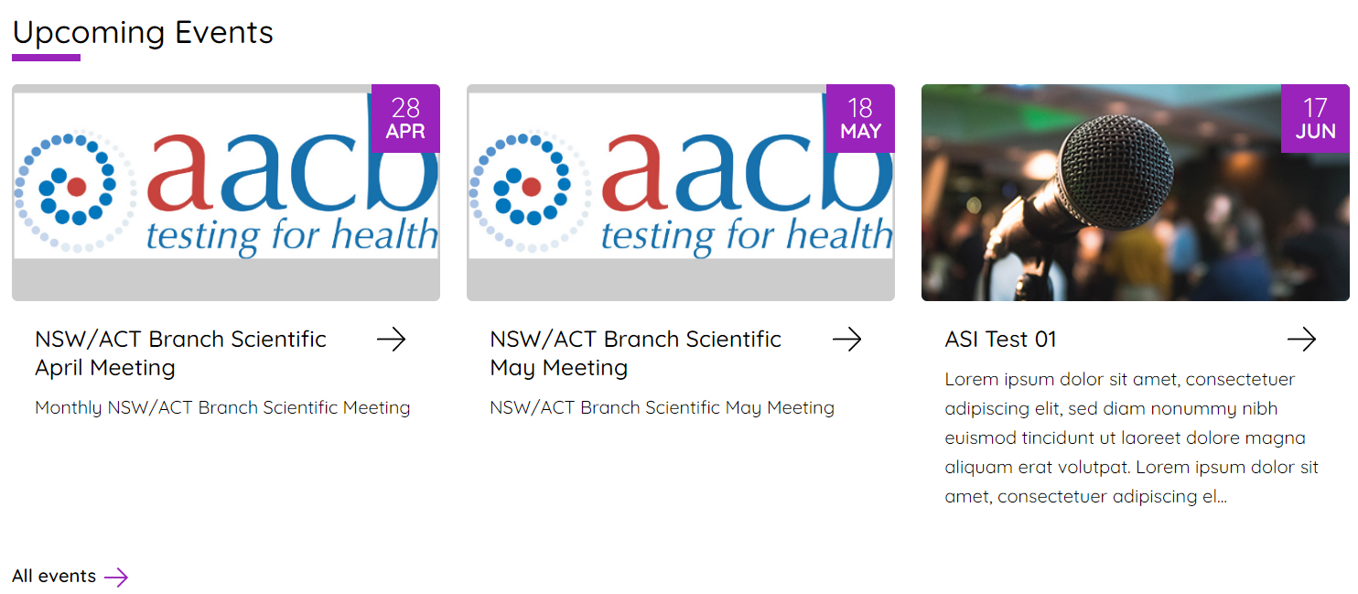

The Upcoming Events section is created using a query located here:
$/_AACB/_AACBSystem/Website/Homepage events

The Query Template iPart needs the classes homeEvents noPadding. Set the number of columns to three.

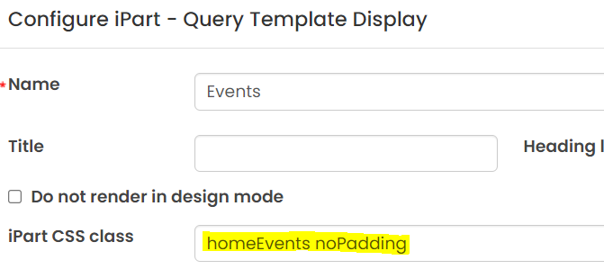

The default filters show upcoming events sorted by soonest first. It shows only the first three results. The query uses some custom SQL fields to format the date, limit the description length to 200 characters and set the image to a default if one is not assigned to the event.
You may change the default image by uploading a new image into the Image Manager to override
/images/MyWebsite/event-default.jpg

It then uses these fields in the Template tab to create the correct HTML structure. If you edit the template, do it in HTML mode.

The ideal size for the image is 415px x 210px. If you want to use a bigger one so it appears larger on the event detail page, keep to this ratio.

Homepage: Latest News

The Latest News section uses a Content Tagged List iPart with a custom Tagged list format, HomeNews. The iPart also uses the classes homeNewsList and noPadding.

Javascript (News JS) in the website template resizes the images to fit the thumbnail area and cuts off the title at 50 characters, and the description at 180 characters.

Images come from the Metatag Image field, which is also used by the Internal Banner.

Follow the specs for the Internal Banner unless you are turning it off on the news article page itself.
In this case the ideal size for the image will be 415px x 210px.

Homepage: Scrolling logos

The image ticker on the home page uses Javascript to animate. To change the images and links, you MUST use HTML view to preserve the styling.

The Javascript required for the marquee to function is inside the iPart labelled Ticker JS on the homepage.
This should not be deleted and must be located beneath the iPart with the marquee images in order to work.

Add or remove an image by deleting or copy/pasting a whole link here:

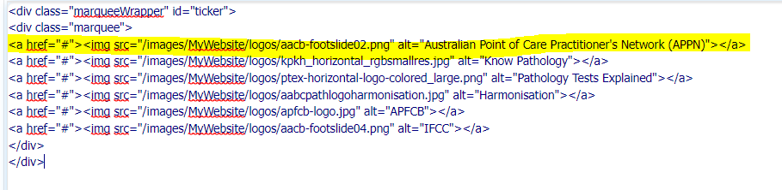

Edit the link between the quotes after href=

You may find it easier to open a page in another tab and add the link into a blank HTML iPart, then copy/paste the generated URL.

To change the image, upload your new image into the iMIS image manager. Image size is not restricted, as they will resize to 100px tall automatically. Logo images should be in colour.

Again, you may find it easier to add the image on another page and copy the source into the new iPart.

Edit the image source between the single quotes here:

Footer: Sitemap links and copyright date

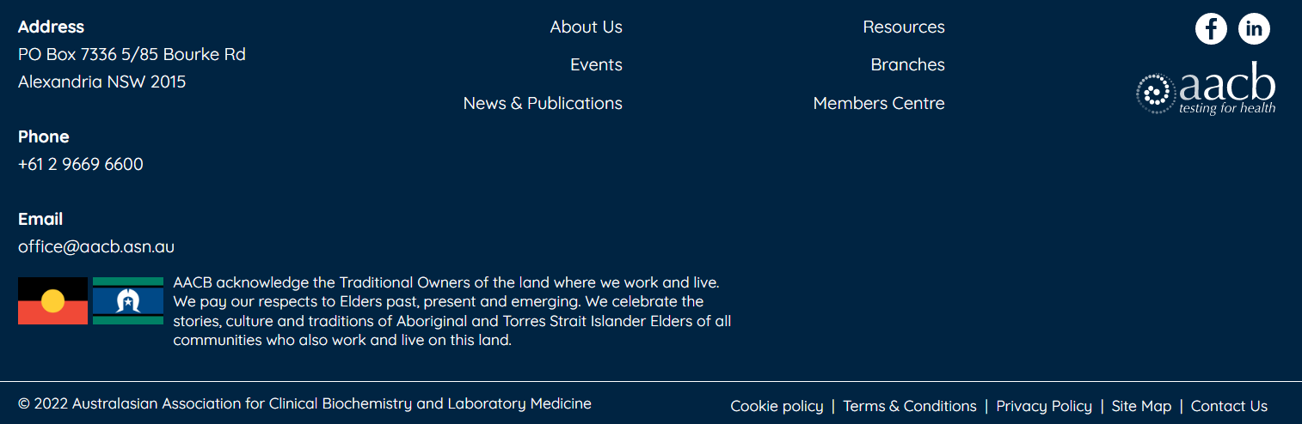

Links in the footer come from the sitemap, using navigation areas
Footer – Cookie policy etc. at the very bottom right
Footer1 – First stack of links About Us etc.
Footer2 – Second stack of links Resources etc.

Other content pulls from the Footer Copyright, Footer Acknowledgement, Footer Contact Us and Footer Socials pages in the ContentAreas folder.

The year in the footer copyright is generated from Javascript found in the website template (Current Year JS).
If you change the wording in the footer, check in HTML mode to make sure you keep the span around the year with the id thisYear.

